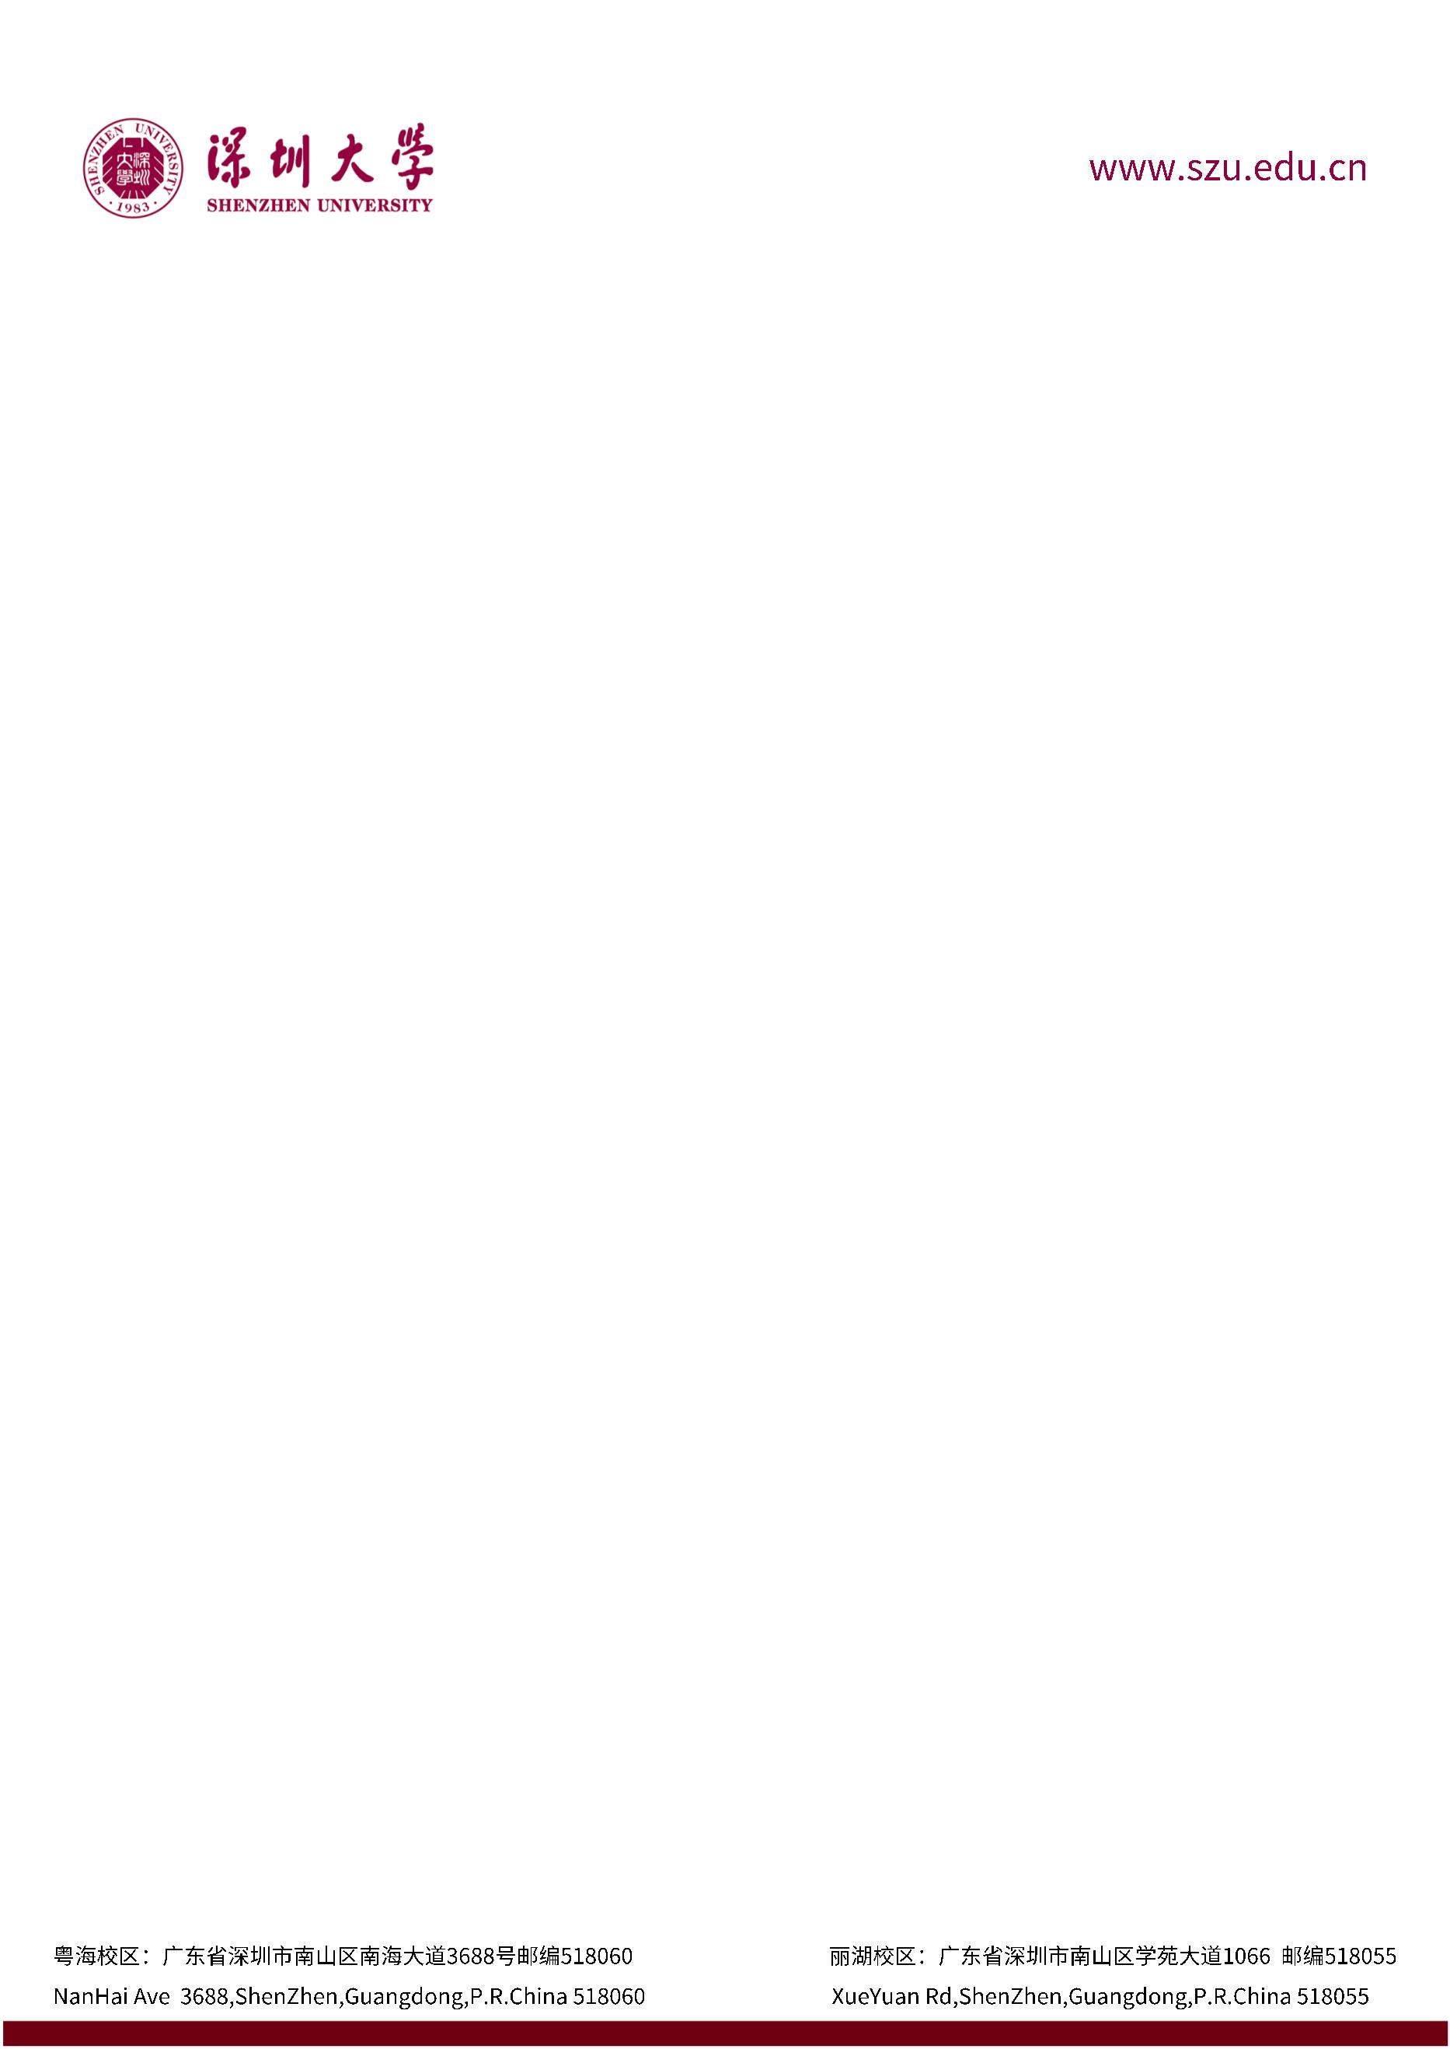

**June 22, 2023**

0755-2653-1309

Dear Admissions Committee,

I am delighted to recommend Huang Liangming for admission to the graduate program in Computer Science at your esteemed institution. I have known Huang since he joined my Data Structures course in March 2023. I am deeply impressed by this student's capabilities and creativity, and I am confident that he is a talented and promising young individual.

One of the most impressive projects Huang Liangming undertook was their research on databases, which was completed as part of their coursework in Data Structures. This project required an in-depth understanding of KV-type databases such as Redis, as well as the ability to conduct independent research, collaborate in teams, and analyze complex information. In the project of building a KV database from scratch, Huang Liangming demonstrated exceptional leadership and collaborative skills. He worked closely with team members to jointly complete the project. Huang Liangming's final report was exemplary, showcasing not only their technical skills but also the ability to work in unity with team members.

Huang Liangming is also actively involved in extracurricular activities, especially those related to computing. They participated in the China College Students' Computer Design Competition and achieved excellent results. In these activities, they not only demonstrated their knowledge and skills but also showed how they apply what they have learned to practical production environments. Their achievements in the field of computing further highlight their well-rounded capabilities and drive for excellence.

Based on Huang Liangming's outstanding performance in courses and competitions, I believe they will thrive at The University of Manchester. They possess the qualities of a promising scholar and a dedicated learner, and I am confident that they will make a positive contribution to your academic community.

Should you require any additional information or have any questions, please feel free to contact me.

Sincerely,

Zhijiao Xiao. Ph D

Associate Professor

Shenzhen University